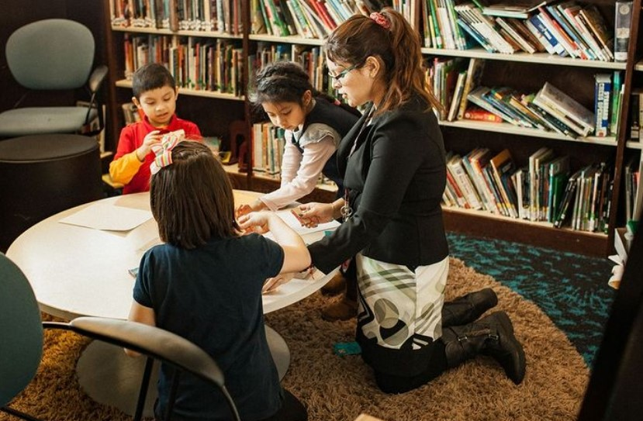

Other Q1 Grants not highlighted previously:



# **By the Numbers**

• • •

The Foundation Board approved grants totaling $832,350 funding 27 organizations during Q2 2023. Grants ranged from $2,500 to $280,000 with the median grant $17,000.

All but two grants had a West Michigan impact. Just 34% of grant dollars were for capital projects. $453,000 or 54% was invested in the Grandville Avenue neighborhood. Due largely to the Potter’s House, 59% of grant dollars went to 12 Christian organizations.

The Foundation has a special relationship with The Potter’s House, a Christian school housed in the Roosevelt Park neighborhood. Peter and Pat supported this school since the beginning and we are proud to continue that partnership. In January, the Foundation committed $230,000 to replace the gym floor with a multi-year grant in addition to providing $50,000 in operating support.

In addition to providing physical fitness classes and a neighborhood gym, the area also serves as a “community room” for a variety of functions and organizations.

Joining some other like-minded funders, we supported some local restaurants by purchasing gift cards for “family friendly budget minded” meals to be distributed by Hand2Hand partners. The program was a needed “win-win” for families and struggling entrepreneurs.

We made our largest single payment capital grant to the organization in first quarter 2021 to help them move from their long-standing church sponsored site, to their own building at 306 Chicago Drive in Jenison. Construction began in February and they hope to be operating from the new space by mid-June. This 15,600 square foot former Aldi store offers them more warehouse space and new spaces – including a Peter C. & Emajean Cook Foundation Community Room. 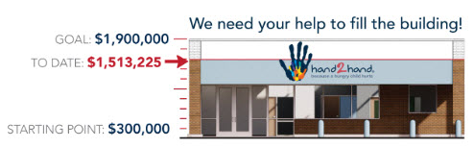

Grandville Avenue Arts & Humanities

As a founding funder of Grandville Avenue Arts & Humanities, Peter and Pat Cook are recognized at both the Cook Arts Center and the Cook Library. Housed in the Roosevelt Park Neighborhood, the Foundation again provided significant operating support ($50,000 to each) for 2023.

The Arts Center provides mentoring and programming for neighborhood youth free of charge through various multi-week sessions.

The Library serves as the community resource center providing traditional reading materials, computer access and homework help.

During the pandemic, GAAH helped youth access on-line learning and provided various essentials.

D

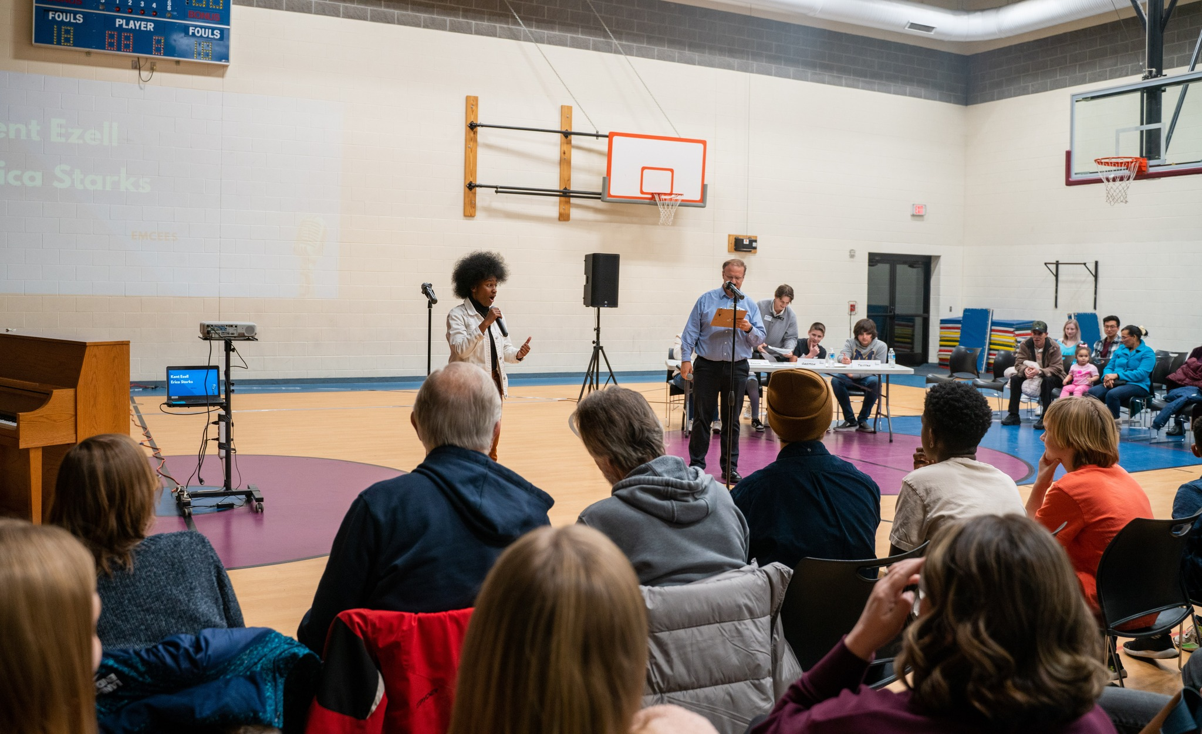

The Foundation’s Mission: With a Christian focus, the Foundation supports and strengthens programs and services that improve the quality of life, community and economy with an emphasis on West Michigan.

For more information, see https://www.cookfoundationgr.org/

Peter C. & Emajean Cook Foundation Q1 2023

|  |  |  |
| --- | --- | --- |
| Newsletter | **3/31/2023** | Released 4/26/23 |